**LINUX FOR USERS**

**Red Hat Family**

* **Fedora** is an ***upstream*** testing platform.
* **CentOS** is a close clone of **RHEL**.
* Uses ***yum*** package manger.

**SUSU Family**

* **SLES** upstream for **openSUSE**.
* Uses **zipper** package manager.
* **YaST** for system admin purposes.
* Used widely for **retailing**.

**Debian Family**

* **Debian** is upstream for **Ubuntu**.
* **DPKG**-based **APT** package manager.
* Widely used for **cloud deployments**.
* **GNOME**-based but differs visually.

**Common Terminologies**

* **Boot loader:** Program that boots the OS.
* **Service:** Program that runs in background process.
* **X window system:** Graphical subsystem.
* **Shell:** Command line interpreter like Bash.

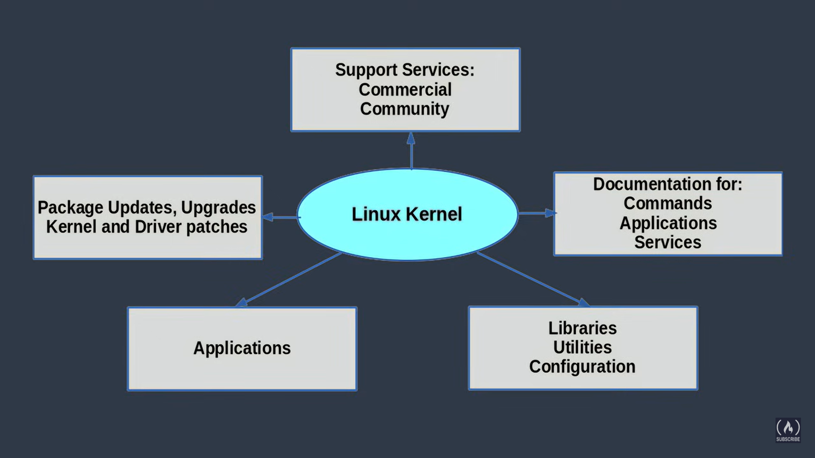

**System Startup**

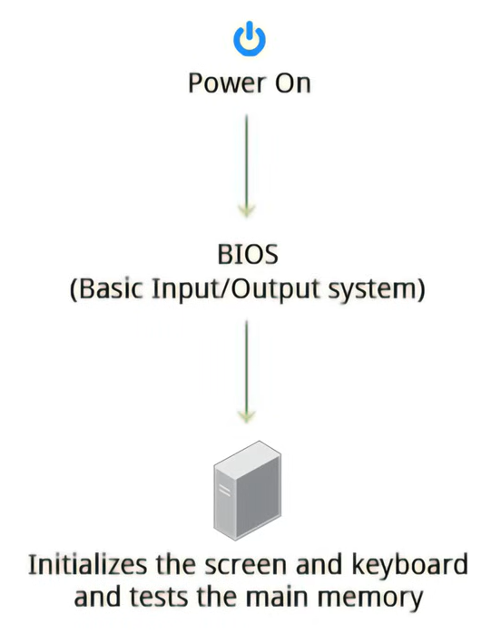

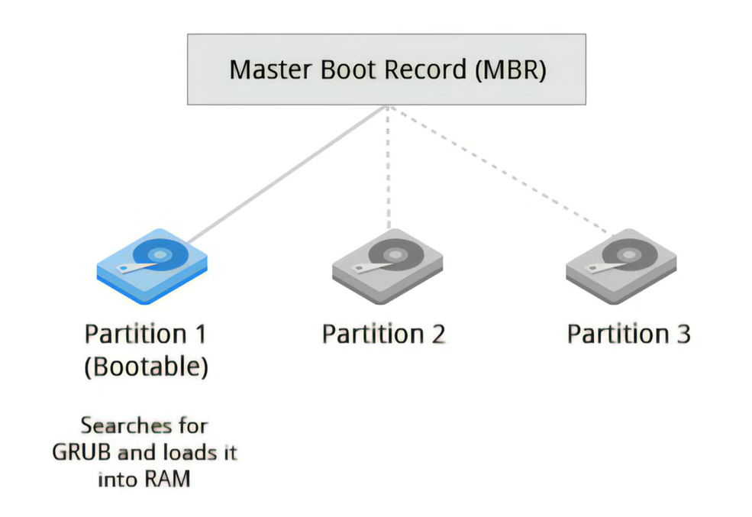

* **GRUB** is a boot loader like ISOLINUX.
* Kernel is in **compressed form** by default which checks if all hardware are in **sync** when booted.

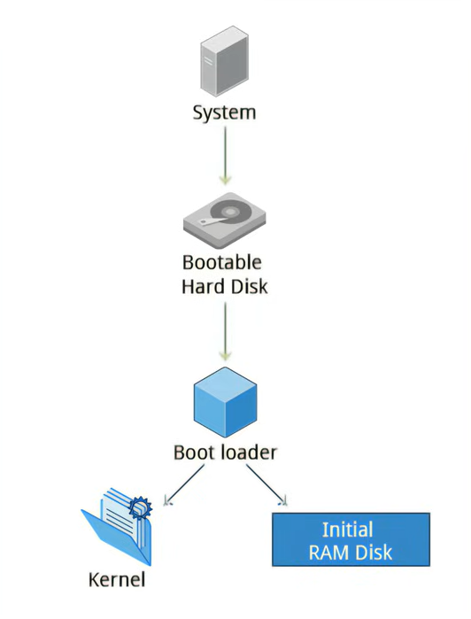

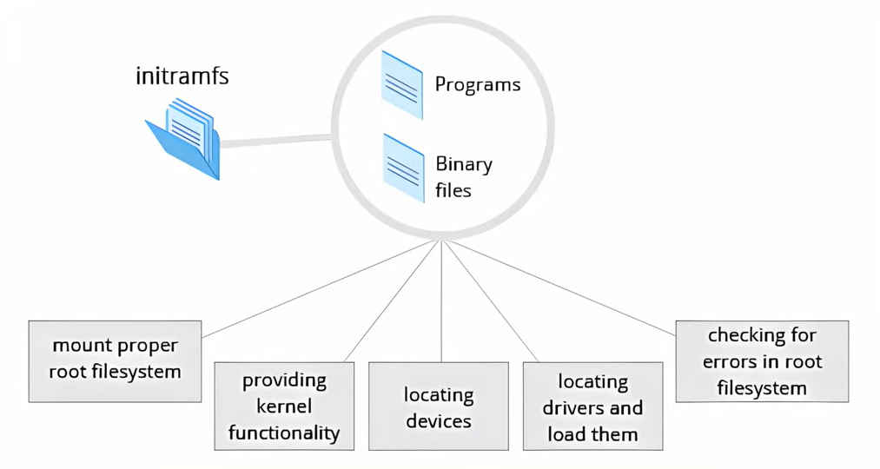

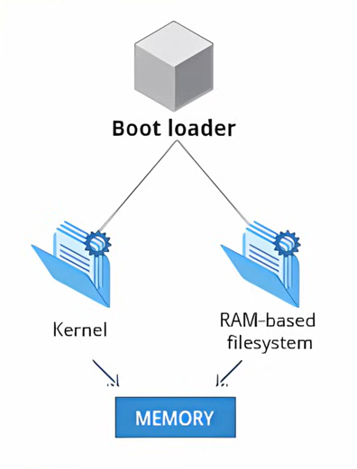

**Process Working**

* **/sbin/init** is the **default working library**.
* **/lib/systemd/system** is the **new** default working library.
* **systemctl** command is used for **basic testing** in terminal.

**Filesystem Hierarchy Standard**

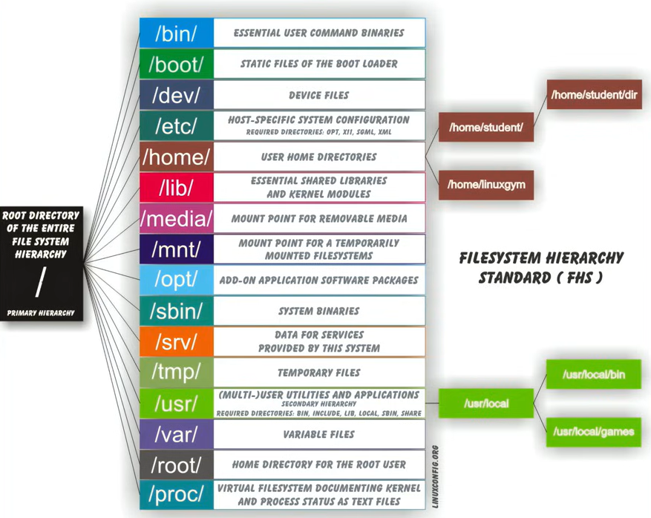

* Files 🡪 Computer 🡪 All FHS files

**Uses of Various Distros**

